Algebra 3-4 Name: ____________________

Section 1.7 - 2.8 Quiz Block: ________

For problems 1 – 2, solve the absolute value equation.

1. 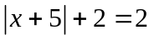 2. 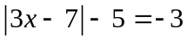

For problems 3-4, solve the absolute value inequality. Then graph your answer on the number line.
3. 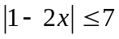 4. 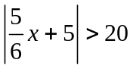

For problems 5-6, graph the absolute value equation.

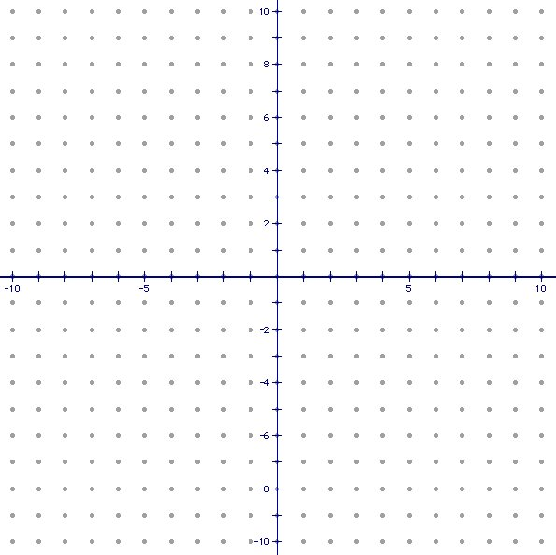
5. 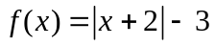 6. 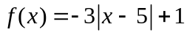

For problem 7, use the following information to answer the problem.

7. A cereal manufacturer has a tolerance of 1.25 ounces for a box of cereal that is supposed to weigh 30 ounces. Write and solve an absolute value inequality that describes the acceptable weights for “30 ounce” boxes.

